Counting Conditional Probability

Permutation
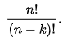
Combination
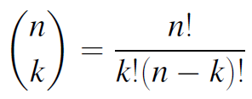

Example:
Ex1: Two balls are ”randomly drawn” from a bowl containing 6 white and 5 black balls. What is the probability that one of the drawn balls is white and the other black?
- Pick 2 balls of 11 balls: 11 * 10 = 110 ways total
- The colors could be BW or WB:
+ If BW: 5 * 6 = 30 ways
+ If WB: 6 * 5 = 30 ways
+ Total: 60 ways
🡪 Probability: 60/110

Ex2: There are n balls of different colors. How many ways to arrange them on a straight line?
- n ways to choose ball on 1st position
- (n-1) ways to choose ball for 2nd …
🡪 n! ways

Ex3: 9 books that he is going to put on his bookshelf. Of these, 4 are mathematics books, 3 are chemistry books and 2 are history books. He wants to arrange his books so that all the books of the same subject are together on the shelf. How many different arrangements are possible?
- 3 blocks of books of same subject: 3! ways to arrange the blocks
- 4! ways for math, 3! For chem, 2! for history
🡪 Total: 3!4!3!2! = 1728 ways

Ex4: A student has to sell 2 books from a collection of 6 math, 7 science, and 4 economics books. How many choices are possible if
a) both books are to be on the same subject?
Answer: 6C2 + 7C2 + 4C2 = 42
b) the books are to be on different subjects?
Answer: This is the number of ways to select any two books minus the number of ways to select them from the same subject. So it is
17C2 – 6C2 – 7C2 – 4C2 = 94
Alternatively, it is
6 * 7 + 7 * 4 + 4 * 6 = 42 + 28 + 24 = 94

Ex5: A club with 10 members needs to select 4 of its members to be on a committee.
a) In how many ways can this be done?
10C4 = 210
b) How many ways can they select the committee if two of the members (named Bob and Carol) are feuding and refuse to serve together?
Because 8C2 is the number of ways that Bob and Carol can both serve:
10C4 – 8C2 = 182
Alternatively, it is:
8C3 + 8C3 + 8C4 = 182
because there are 8C3 ways that Bob can serve without Carol, 8C3 ways that Carol can serve without Bob and 8C4 ways that neither serve.

Bayes Independence

Conditional Probability
P(A|B) = $\frac{P\left(AB\right)}{P\left(B\right)}$

Total probability formula:
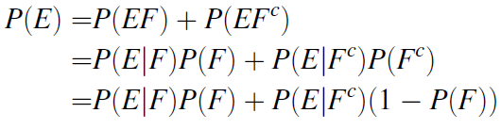

Example
Ex1: An ordinary deck of 52 playing cards is randomly divided into 4 piles of 13 cards each. Compute the probability that each pile has exactly 1 ace.
Define events E_{i}, i = 1; 2; 3; 4:
E₁ = {ace of spades is in any one of the piles}
E₂ = {ace of spades and ace of hearts are in different piles}
E₃ = {aces of spades, hearts, and diamonds are all in different piles}
E₄ = {4 aces are in different piles}
P(E₁) = 1
P(E₂|E₁) = (52 - 13)/(52 - 1) = 39/51
P(E₃|E₁E₂) = (52-13*2)/(52 - 2) = 26/50
P(E₄|E₃E₂E₁) = (52-13 * 3)/(52 – 3) = 13/49
P(E₄) = P(E₁E₂E₃E₄) = P(E₁)P(E₂|E₁)P(E₃|E₁E₂)P(E₄|E₁E₂E₃) = 1 * ….

Ex2: An insurance company thinks that there are some people who are accident prone and others who are not. An accident-prone person will have an accident at sometime within 1 year with probability .4, whereas this probability is .2 for other person. Assume that 30 percent of the population is accident prone, what is the probability that a new policy holder will have an accident within a year of purchasing a policy?
E = {new customer will have accident}
F = {new customer is accident prone}
P(F) = 0.3
P(E|F) = 0.4
P(E|F^{C}) = 0.2
By Bayes: P(E) = P(E|F) * P(F) + P(E|F^{C}) * P(F^{C}) = 0.26

Midterm Sem 1 – 2018

1) From a group of 8 women and 6 men, a committee consisting of 3 men and 3 women is to be formed. How many different committees are possible if:
a) 2 of the men refuse to serve together
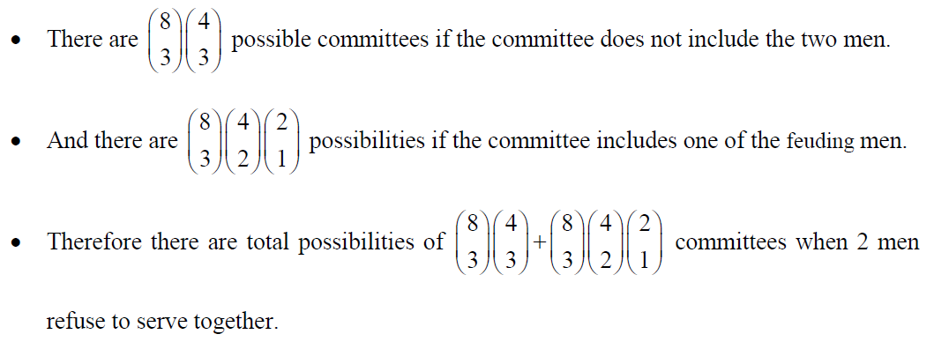
b) 2 of the women refuse to serve together
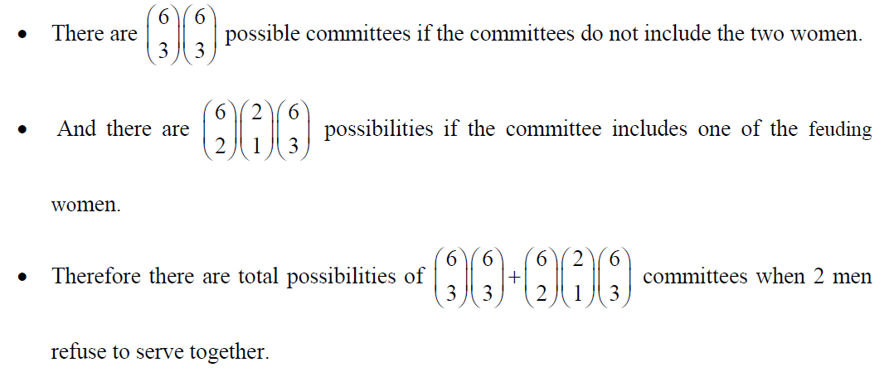
b) 1 man and 1 woman refuse to serve together
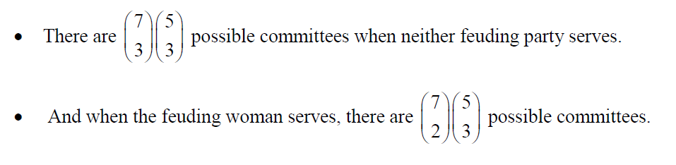
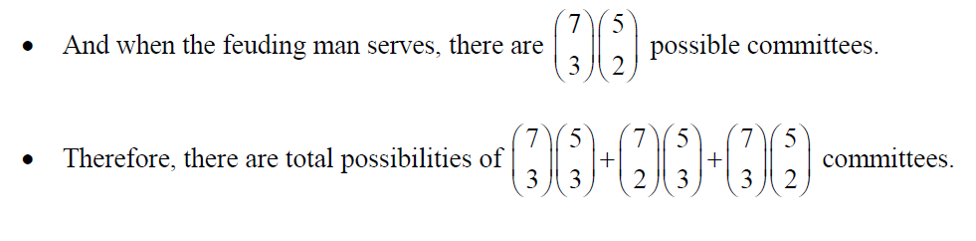

2) Sixty percent of the students at a certain school wear neither a ring nor a necklace. Twenty percent wear a ring and 30 percent wear a necklace. If one of the students is chosen randomly, what is the probability that this student is wearing.
Let A be the event that the student is wearing a ring, B be the event the student is wearing a necklace. Then
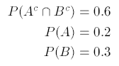
a) a ring or a necklace
b) a ring and a necklace
3) On rainy days, Joe is late to work with probability 0.3; on non-rainy days, he is late with probability 0.1. With probability 0.7, it will rain tomorrow.
Let R be the event that it rains tomorrow, and L be the event that Joe is late tomorrow.
a) Find the probability that Joe is early tomorrow.
By the law of total probability, the probability that Joe is early (not late) tomorrow is:
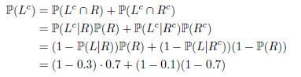
b) Given that Joe was early, what is the conditional probability that is rained?
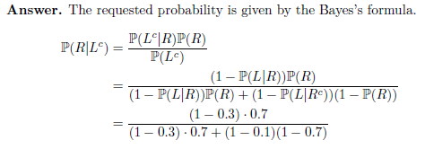

4) A box contains 80 new batteries and 20 used batteries.
a) Pick 2 batteries from the box at random and without replacement. Let A₁ be the event that the first battery is used, and A₂ be the event that the second battery is used. Compute P(A₁) and P(A₂). Are they the same?
b) Are A₁ and A₂ independent? Explain your reason.
c) Pick 10 batteries from the box at random with replacement. Let X be the number of used batteries among the picked batteries. Calculate P(X>1), E(X) and Var(X)

